**Hybrid Repository.**

**Introduction:**

One of the goals of the HYBRID modeling and simulation project is to assess the economic viability of hybrid systems in a market that contains renewable energy sources like wind. The hybrid system would be a nuclear reactor that not only generates electricity, but also provides heat to another plant that produces by-products, like hydrogen or desalinated water. The idea is that the possibility of selling heat to a heat user absorbs (at least part of) the volatility introduced by the renewable energy sources.

The system that is studied is modular and made of an assembly of components. For example, a system could contain a hybrid nuclear reactor, a gas turbine, a battery and some renewables. This system would correspond to the size of a balance area, but in theory any size of system is imaginable. The system is modeled in the ‘Modelica/Dymola’ language.

To assess the economics of the system, an optimization procedure is varying different parameters of the system and tries to find the minimal cost of electricity production.

**Modelica Models:**

Idaho National Laboratory (INL) has been developing a library of high-fidelity process models in the commercial Modelica language platform Dymola since early 2013 [1],[2],[3],[4]. The Modelica language is a non-proprietary, object oriented, equation-based language that is used to conveniently model complex, physical systems. Modelica is an inherently time-dependent modeling language that allows the swift interconnection of independently developed models. Being an equation-based modeling language that employs differential algebraic equation (DAE) solvers, users can focus on the physics of the problem rather than the solving technique used, allowing faster model generation and ultimately analysis. This feature alongside system flexibility has led to the widespread use of the Modelica language across industry for commercial applications. System interconnectivity and the ability to quickly develop novel control strategies while still encompassing overall system physics is why INL has chosen to develop the Integrated Energy Systems (IES) framework in the Modelica language.

**Primary Heat System:**

***Westinghouse 4-Loop:***

* The Westinghouse 4-loop system is designed to be consistent with publicly available information on the Westinghouse plant design. This is a Pressurized Water reactor with a nominal thermal power of 3465MWt and has control systems designed to output 1100MWe.

***Generic Modular PWR***

* The generic modular PWR unit is sized to be 160 MWt with 50MWe output as is consistent with the NuScale power module. However, the generic modular PWR does not operate under natural circulation but instead operates under forced flow. Therefore, this unit provides more stability in the code since it does not rely on density differentials to drive flow. This makes the unit less useful than is the NuScale style reactor modeled below, but it does provide the user a power input consistent with NuScale style systems but without the need to tune system geometries, friction factors, etc.. to meet the proper flow dynamics.

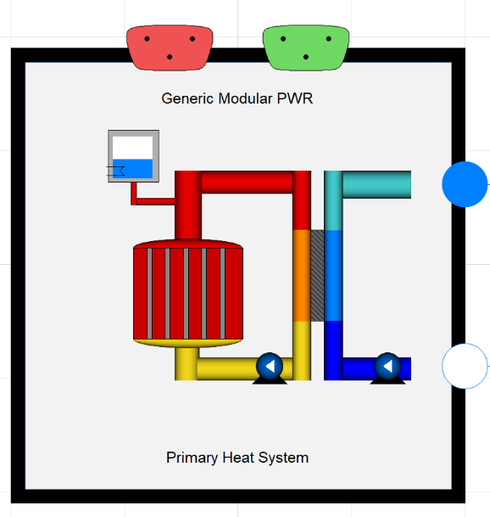

***NuScale Style Reactor:***

* The NuScale power module is an integral pressurized water reactor (IPWR) that operates with a nominal thermal power of 160 MWt capable of producing 50 MWe to the electric grid. Integral designs are fully self-contained, eliminating the need for large main steam lines that can potentially lead to large break loss of coolant accidents (LOCA). Instead the primary system has only an inlet of feed water into the bottom of the helical coil steam generator and an exit point for steam at the top of the steam generator.

The primary system does not include any pumps but instead operates under natural circulation. Natural circulation reactors rely on the height and density differentials between hot and cold water to drive circulation of water through the core. Through elimination of primary coolant pumps an entire class of accident scenarios is eliminated. Modeling efforts in this report focused on three main efforts: matching thermal and electric output, matching system geometry, and matching natural circulation efforts in the system via flow rates and temperature differentials. The primary side of the module has heights and cross sectional areas in accordance with NRC design certification material. The primary and secondary sides were modeled in their entirety. The helical coil steam generator was modeled as a once through steam generator where the secondary side is on the inside of the tubes and the primary side fluid run along the outside of the tubes. The full report on the NuScale Power module is available on OSTI.

* [<https://www.osti.gov/biblio/1569288-status-report-nuscale-module-developed-modelica-framework>]. -- Frick, Konor L. *Status Report on the NuScale Module Developed in the Modelica Framework*. United States: N. p., 2019. Web. doi:10.2172/1569288.

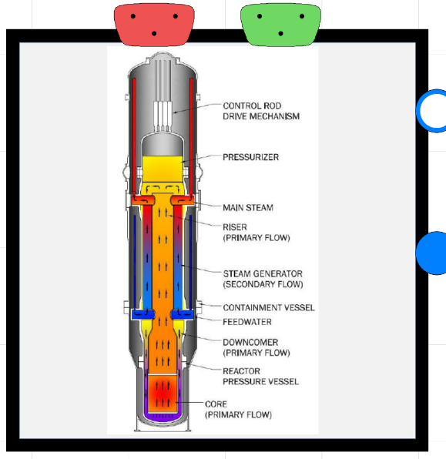

**Energy Manifold:**

* The energy manifolds intention is be a diversion module to as many different subunits as needed for fluid diversion. It consists of a series of pipes that can be extended to “n” submodules. The unit has the capability of utilizing control schemes, however in many practical applications the control schemes are encapsulated within the subprocesses as opposed to within the energy manifold.

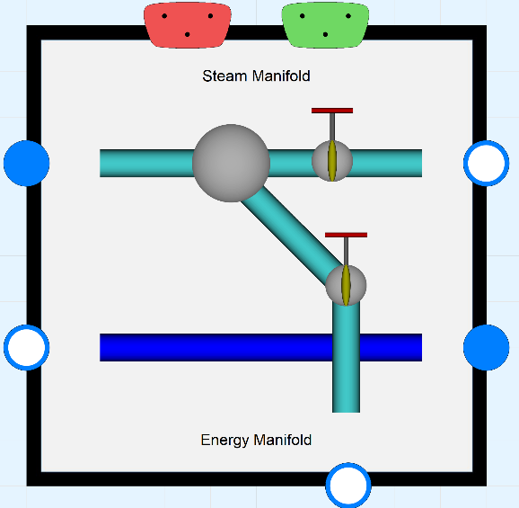

**Balance of Plant:**

* The balance of plant system consists of an ideal steam turbine model, a condenser, feedwater system for reheat, and a couple of valves that allow steam flow either to the turbine or as a bypass to the condenser. Additionally, piping exists to send condensate and rejected heat from ancillary processes directly to the condenser. The balance of plant model can handle supervisory control input for direct control of the turbine control valve and turbine bypass valve based on different sensor input.

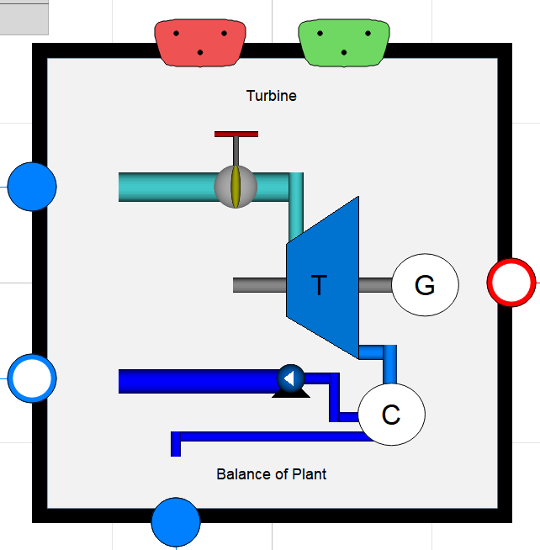

***StepDown Turbines:***

* The step-down turbines consist of a series of a ideal steam turbines connected via a singular rotational inertia shaft with bypass tap lines coming off the turbines. The purpose of this model is to allow turbine tap offtake in a dynamic system.

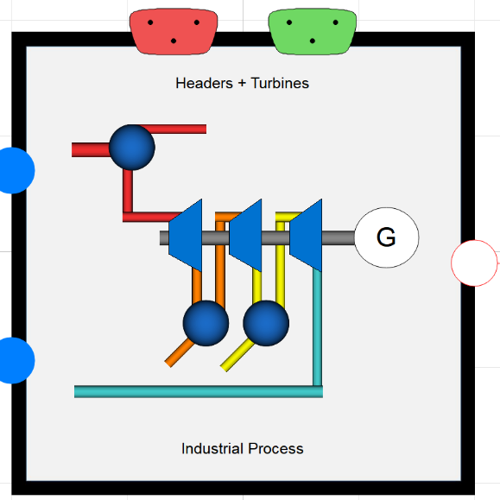

**Hydrogen Production:**

* The hybrid repository includes hydrogen production via high temperature steam electrolysis (HTSE). HTSE utilizes a combination of thermal energy and electricity to split water into hydrogen (H2) and oxygen (O2) in SOECs, which can be seen in simple terms as the reverse operation of solid oxide fuel cells (SOFCs). The cathode-supported cell consists of a three-layer solid structure (composed of porous cathode, electrolyte, and porous anode) and an interconnect (separator) plate [13]. An oxygen-ion conducting electrolyte (e.g., yttria-stabilized zirconia [YSZ] or scandia-stabilized zirconia [ScSZ]) is generally used in SOECs [14]. For electrically conducting electrodes, a nickel cermet cathode, and a perovskite anode such as strontium-doped lanthanum manganite (LSM) are typically used. The interconnect plate separates the process gas streams; it must also be electrically conducting and is usually metallic, such as a ferritic stainless steel. Full details on the model are available in two reports.
* <https://www.osti.gov/biblio/1408745-status-report-high-temperature-steam-electrolysis-plant-model-developed-modelica-framework-fy17> -- Kim, Jong Suk, Bragg-Sitton, Shannon M., and Boardman, Richard D. *Status Report on the High-Temperature Steam Electrolysis Plant Model Developed in the Modelica Framework (FY17)*. United States: N. p., 2017. Web. doi:10.2172/1408745.
* <https://www.osti.gov/biblio/1333156-status-component-models-developed-modelica-framework-high-temperature-steam-electrolysis-plant-gas-turbine-power-plant> -- Suk Kim, Jong, McKellar, Michael, Bragg-Sitton, Shannon M., and Boardman, Richard D. *Status on the Component Models Developed in the Modelica Framework: High-Temperature Steam Electrolysis Plant & Gas Turbine Power Plant*. United States: N. p., 2016. Web. doi:10.2172/1333156.

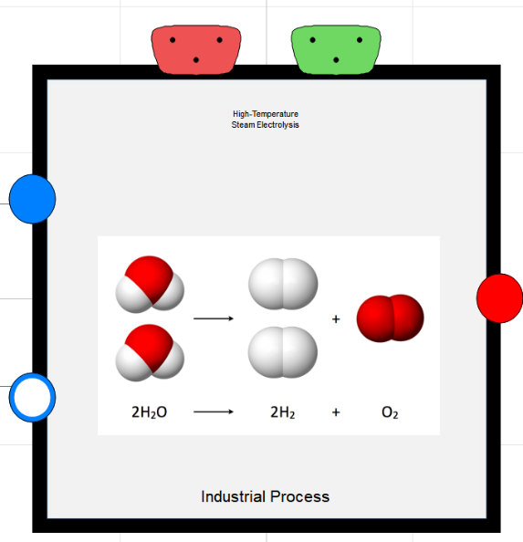

**Desalination:**

* RO desalination utilizes a semi-permeable membrane, which allows water to pass through but not

salts, thus separating the fresh water from the saline feed water. A typical Brackish Water RO (BWRO) plant consists of four main components: feed water pretreatment, High-Pressure (HP) pumping, membrane separation, and permeate (fresh water) post-treatment. The concentrate water rejected by the first membrane module plays a role as the feed water for the second membrane module by the successive order, and so on. These pressure vessels are arranged in rows in each membrane stage, with two-stage membrane separation being typical in BWRO. Each stage has a recovery of 50–60%, achieving overall system recovery of 70–85% [7].

* <https://www.osti.gov/biblio/1357452-modeling-control-dynamic-performance-analysis-reverse-osmosis-desalination-plant-integrated-within-hybrid-energy-systems>. Kim, Jong Suk, Chen, Jun, and Garcia, Humberto E. *Modeling, control, and dynamic performance analysis of a reverse osmosis desalination plant integrated within hybrid energy systems*. United States: N. p., 2016. Web. doi:10.1016/j.energy.2016.05.050.
* <https://www.osti.gov/biblio/1468648-status-report-component-models-developed-modelica-framework-reverse-osmosis-desalination-plant-thermal-energy-storage>--Kim, Jong Suk, and Frick, Konor. *Status Report on the Component Models Developed in the Modelica Framework: Reverse Osmosis Desalination Plant & Thermal Energy Storage*. United States: N. p., 2018. Web. doi:10.2172/1468648.

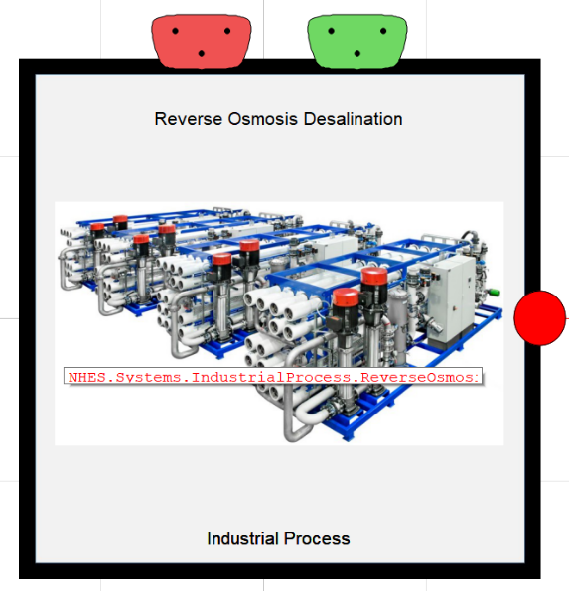

**Energy Storage:**

Electric Battery Storage is largely characterized as fast and expensive. Due to the speed with which battery storage systems operate, on the order milliseconds, the battery within the hybrid repository has been modeled as a simple logical battery system. The battery can both charge and discharge based upon the direction of electricity flow through the port. It is assumed to be a “perfect” battery and due to the speed of the system, subcomponents have not been modeled simply because they would operate faster than would be useful for the types of analysis utilized with the system.

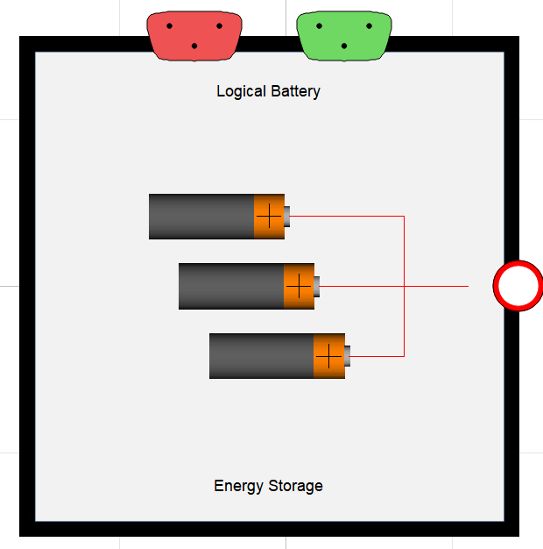

Sensible heat storage involves the heating of a solid or liquid without phase change and can be

deconstructed into two operating modes: charging and discharging. A two-tank TES system is a common

configuration for liquid sensible heat systems. In the charging mode cold fluid is pumped from a cold

tank through an Intermediate Heat Exchanger (IHX), heated, and stored in a hot tank while the opposite

occurs in the discharge mode. Such systems have been successfully demonstrated in the solar energy field

as a load management strategy.

The configuration of the TES system held within the repository involves an outer loop interfaces with the energy manifold. Bypass steam is directed through an IHX and ultimately discharged to the main condenser of an Integrated system. An inner loop containing a TES fluid consists of two large storage tanks along with several pumps to transport the TES fluid between the tanks, the IHX and a steam generator. Flow Bypass Valves (FBVs) are included in the discharge lines of both the “hot” and “cold” tanks to prevent deadheading the pumps when the Flow Control Valves (FCVs) are closed. Therminol-66 is chosen as the TES fluid as it is readily available, can be pumped at low temperatures, and offers thermal stability over the range (-3°C–343°C) which covers the anticipated operating range of the light water reactor systems (203°C–260°C). Molten salts (e.g. 48% NaNO3 – 52% KNO3) were not considered, as the anticipated operating temperatures fall below their 222°C freezing temperature [17]. The TES system is designed to allow the reactor to run continuously at ~100% power over a wide range of operating conditions. During periods of excess capacity, bypass steam is directed to the TES unit through the auxiliary bypass valves where it condenses on the shell side of the IHX. TES fluid is pumped from the cold tank to the hot tank through the tube side of the IHX at a rate sufficient to raise the temperature of the TES fluid to some set point. The TES fluid is then stored in the hot tank at constant temperature. Condensate is collected in a hot well below the IHX and drains back to the main condenser or can be used for some other low pressure application such as chilled water production, desalination or feed-water heating. The system is discharged during periods of peak demand, or when process steam is desired, by pumping the TES fluid from the hot tank through a boiler (steam generator) to the cold tank. This process steam can then be reintroduced into the power conversion cycle for electricity production or directed to some other application through the PCV. A nitrogen cover gas dictates the tank pressures during charging and discharging operation.

* <https://www.osti.gov/biblio/1468648-status-report-component-models-developed-modelica-framework-reverse-osmosis-desalination-plant-thermal-energy-storage>--Kim, Jong Suk, and Frick, Konor. *Status Report on the Component Models Developed in the Modelica Framework: Reverse Osmosis Desalination Plant & Thermal Energy Storage*. United States: N. p., 2018. Web. doi:10.2172/1468648.
* <https://www.osti.gov/biblio/1557660-design-operation-sensible-heat-peaking-unit-small-modular-reactors> -- Frick, Konor, Doster, Joseph Michael, and Bragg-Sitton, Shannon. *Design and Operation of a Sensible Heat Peaking Unit for Small Modular Reactors*. United States: N. p., 2018. Web. doi:10.1080/00295450.2018.1491181.

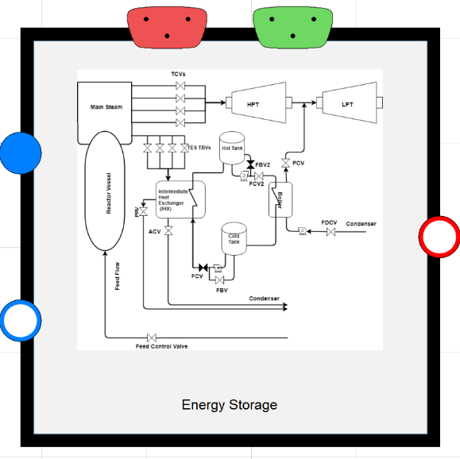

**Natural Gas Turbine:**

Recently, natural gas-fired turbines have found widespread use because of their higher efficiencies,

lower capital costs, shorter installation times, abundance of natural gas supplies, lower greenhouse gas

emissions compared to other energy sources; and fast start-up capability, which enables them to be used

as peaking units that respond to peak demands [22, 23]. Due to their special characteristics, natural gasfired turbines are installed in numerous places around the world and have become an important source for power generation. This section is dedicated to detailed process and control designs of the GTPP, whose primary role is to cover rapid dynamics in grid demand that cannot be met by the remainder of the N-R HES. Simulation results involving several case studies are also provided.

* <https://www.osti.gov/biblio/1333156-status-component-models-developed-modelica-framework-high-temperature-steam-electrolysis-plant-gas-turbine-power-plant> -- Suk Kim, Jong, McKellar, Michael, Bragg-Sitton, Shannon M., and Boardman, Richard D. *Status on the Component Models Developed in the Modelica Framework: High-Temperature Steam Electrolysis Plant & Gas Turbine Power Plant*. United States: N. p., 2016. Web. doi:10.2172/1333156.

